Administrative Leadership Team
Monthly Meeting Notes
November 7, 2023
10:00 – 12:00 pm
E254 AJB

Present: Angie Bellew, Liz Cecil, Margaret Driscol, Troy Fitzpatrick, Pat Goodwin, Sarah Horgen, Julie Jones, Justin Kahler, Sasha Khmelnik, Gabbie McDermott, Barb Pooley, Alli Rockwell, Rosie Ver Steegh, Tammy Siegel, Becca Tritten, Lindsay Vella, Chuck Wieland

Absent: Becky Kick, Ruthina Malone, Heather Mineart, Shonda Monette

Guests: Tom Koeppel, Liz Mendez-Shannon, Melia Pieper, Julie Rothbardt, Tiffany Schier

- Welcome and General Announcements
Tiffany Schier welcomed the group (due to Becca Tritten running late from the CLAS EC meeting) and the meeting started with updates from HR. Later, Becca provided general updates around the following:
Items of note:
- EC continues to review and work on the CLAS MOPP Revision Proposal. It is possible that EC will conclude their work next week and will move on to other agenda items.
- Becca and Sara discussed the dotted line proposal with the DEOs at this week’s DEO Meeting. Becca provided an update on how the conversation went, which overall she felt like went well. Next step is presenting this structure to the CLAS Executive Committee. If supported, this plan would go into effect July 1, 2024.

- Updates
Tom Koeppel, Julie Rothbardt, Melia Pieper, Tiffany Schier, and Rosie Ver Steegh provided the following monthly updates:

Julie & Melia updates (HR):
Julie: Julie presented slides and she said she would be emailing them all out to you as part of her monthly update.

Melia:
Announcement
- If an employee has a Domestic partner affidavit’s on file with the Benefits Office, the partner would qualify as a spouse for FMLA purposes.

Search updates
Offers accepted:
- Maggie Vogel started as Facilities Manager November 1st
- Jonna Higgins-Freese starts as Senior IT Director December 1st

Verbal offer extended:
- Associate Director, Student Services
- Faculty Affairs Specialist, Office of the Dean

Interviewing
- Associate Director, Curriculum and Instruction
- Admin Services Manager, Office of the Dean

Posting soon
- Senior Behavioral Health Clinician (donor funded)
- Several Senior Academic Advisor positions

Tiffany updates (Faculty Affairs):
- ITF policy: The University developed a new Instructional Track Faculty policy that will go into effect January 1, 2024. CLAS is working on our plan for aligning our ITF policy with the changes and the implementation timeline. I will provide updates again when available.
- 11/1 preliminary promotion record submission deadline: thanks to everyone that submitted a preliminary promotion record! We are reviewing them and will reach out if anything needs attention. You can still send documents for review; it will take a bit to get through them all.
- Promotion Cover Sheets and new P&T Dashboard tab in the Faculty Admin Center (FAC):
  - The location for accessing the Promotion Cover sheet has moved within the FAC system. Previously it was available on the “Faculty Review” tab. The Provost’s Office has developed a new “Promotion & Tenure” tab where it now resides. To initiate the cover sheet, navigate to the “Promotion & Tenure” tab. Click the “START” button in the “Cover Sheet” column. Fill out the necessary fields and submit to workflow by the CLAS P&T deadline:
    - 12/4: Promotion Records due for ITF (all ranks), CT (all ranks), and TT to Associate Professor
    - 12/11: Promotion Records due for TT to Full Professor
  - Please do not upload anything in the “Documents” column of the “Promotion & Tenure” tab. This is a new system built for colleges to submit the final promotion record to the Provost’s Office after CCG and the Dean’s review. Departments will continue to submit their final promotion records to CLAS via the clas-pt@uiowa.edu email or the File Cabinet (if under 50MB).
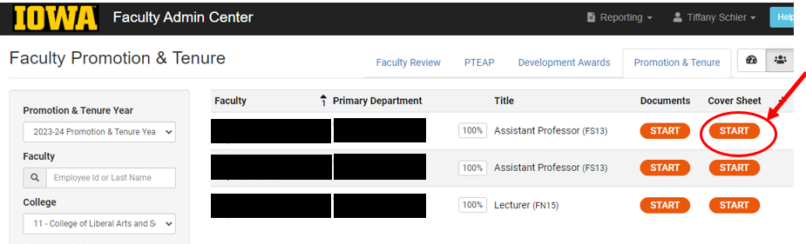
- Faculty line pre-proposals: New this year, we are reaching out to several departments that requested a 24/25 search in their 5-year faculty hiring plan if the college will not be able to strategically consider a hire in their requested area next year. The ADs are reaching out in advance of the 11/17 pre-proposal deadline to let DEOs/Admins know we will not ask them to submit a pre-proposal for consideration this year. Please feel free to reach out to your Area AD if you have questions or would like to discuss your unit’s strategic planning process moving forward.
- Reminder of upcoming deadlines:
  - 11/17: Faculty line Pre-Proposals due
  - 11/17: Faculty deployment charts for 24/25 due. Include all adjunct/visitor needs
  - 12/8: Visitor/adjunct/overload requests for 24/25

Tom updates (Finance):
Reminder of Payroll Cutoff
Normal reporting for employee time record data sent electronically or online via self-service is to be in payroll by Wednesday, November 15 at 5:00 p.m. to allow for the Thanksgiving holiday.

Monthly payroll cutoff will be Wednesday, November 22 at 5:00 p.m.

Biweekly payroll cutoff for the November 21 payroll (biweekly time-period October 29-November 11) will be Tuesday, November 14 at 5:00 p.m. Biweekly time records are due on Tuesday, November 14 at 5:00 p.m.

Rosie Ver Steegh (Staff Council):
No new updates at this time.

- CLAS DEI
Liz Mendez-Shannon presented to the group information about her DEI Roadmap, which provided context about CLAS initiatives she is leading and the work that is being done campus wide.

- CLAS HR Hub
Melia Pieper, presented some updates on CLAS HR Hub Processes. The PowerPoint for that has been provided separately.

End of Meeting.

